**E-COMMERCE WEBSITE FOR ONLINE BOOK SALE**

**Real time Research Project (CS456PC)**

**Submitted**

in partial fulfilment of the requirements for completion of

**Bachelor of Technology IV Semester**

in

**Computer Science Engineering**

by

**B.DEEKSHITHA PRASANNA (22261A0504)**

and

**CHINTHALA SWEETY (22261A0517)**

Under the guidance of

**Dr. Meera Alphy  
(Assistant Professor)**

and

**Mrs. K.Shirisha**

**(Assistant Professor)**



**Department of computer science enginnering**

**MAHATMA GANDHI INSTITUTE OF TECHNOLOGY(A)**

Gandipet, Hyderabad-500075,Telangana(INDIA)

2023-2024

**MAHATMA GANDHI INSTITUTE OF TECHNOLOGY**

Gandipet, Hyderabad-500 075, Telangana (India)

# CERTIFICATE

# 

This is to certify that the Real-time Research (CS456PC) **E-COMMERCE WEBSITE For ONLINE BOOK SALE** is being submitted by **B.DEEKSHITHA PRASANNA** bearing **Roll No: 22261A0504** and **CHINTHALA SWEETY** bearing **Roll No: 22261A0517** in partial fulfillment for completion of **IV Semester** in **Computer Science and Engineering** to **Mahatma Gandhi Institute of Technology** is a record of bona-fide work carried out by him under our guidance and supervision. The report is based on the work done entirely by us and not copied from any other source.

**Project Guide** **Head of the Department**

**Dr. Meera Alphy Dr. C.R.K Reddy**

Asst. Professor, Dept. of CSE Professor, Dept. of CSE

Project Guide

**Ms.K.Shirisha**

Asst. Professor, Dept. of CSE

# DECLARATION

This is to certify that the work reported in Real-Time Research Project (CS456PC) titled “**E-COMMERCE WEBSITE For ONLINE BOOK SALE”** is a record of work done by us in the Department of Computer Science and Engineering, Mahatma Gandhi Institute of Technology, Hyderabad. No part of the work is copied from books/journals/internet and wherever the portion is taken, the same has been duly referred in the text. The report is based on the work done entirely by us and not copied from any other source.

**B. DEEKSHITHA PRASANNA**

**(22261A0504)**

**CHINTHALA SWEETY**

**(22261A0517)**

# ACKNOWLEDGEMENT

The satisfaction that accompanies the successful completion of any task would be incomplete without the mention of people who made it possible because success is the abstract of hard work and perseverance, but steadfast of all is encouraging guidance. So, we acknowledge all those whose guidance and encouragement served as a beacon light and crowned my efforts with success.

We would like to express our sincere thanks to Dr. **G. Chandra Mohan Reddy, Principal MGIT**, for providing the working facilities in college.

We wish to express our sincere thanks and gratitude to **Dr. C R K Reddy, Professor and HOD**, Department of CSE, MGIT, for all the timely support and valuable suggestions during the period of project.

We are extremely thankful to **Dr. Meera Alphy Assistant Professor & Ms. K. Shirisha Assistant Professor,** Department of CSE, MGIT, Real-Time Research Project Coordinators for their encouragement and support throughout the project.

Finally, we would also like to thank all the faculty and staff of CSE Department who helped us directly or indirectly in completing this project.

**B.DEEKSHITHA PRASANNA**

**(22261A0504)**

**CHINTHALA SWEETY**

**(22261A0517)**

**TABLE OF CONTENTS**

|  |  |
| --- | --- |
|  |  |
| **CERTIFICATE** | [**i**](https://docs.google.com/document/d/1kiGDgrMDIR8I_VXyAooZSxCG0YCbo3bliZK_QagFetY/edit#heading%3Dh.30j0zll)**i** |
| **DECLARATION** | [**ii**](https://docs.google.com/document/d/1kiGDgrMDIR8I_VXyAooZSxCG0YCbo3bliZK_QagFetY/edit#heading%3Dh.3znysh7)**i** |
| **ACKNOWLEDGEMENT** | **iv** |
| **LIST OF FIGURES** | [**vi**](https://docs.google.com/document/d/1kiGDgrMDIR8I_VXyAooZSxCG0YCbo3bliZK_QagFetY/edit#heading%3Dh.1t3h5sf) |
| **LIST OF TABLES** | **vii** |
| **ABSTRACT** | **v**[**ii**](https://docs.google.com/document/d/1kiGDgrMDIR8I_VXyAooZSxCG0YCbo3bliZK_QagFetY/edit#heading%3Dh.4d34og8)**i** |
| **1. INTRODUCTION** | [**1**](https://docs.google.com/document/d/1kiGDgrMDIR8I_VXyAooZSxCG0YCbo3bliZK_QagFetY/edit#heading%3Dh.2s8eyo1) |
| 1.1 Problem Statement | 1 |
| 1.2 Objectives | 1 |
| 1.3 Existing System and its Disadvantages | [2](https://docs.google.com/document/d/1kiGDgrMDIR8I_VXyAooZSxCG0YCbo3bliZK_QagFetY/edit#heading%3Dh.26in1rg) |
| 1.4 System Requirements | 4 |
| 1.4.1 Software Requirements | 4 |
| 1.4.2 Hardware Requirements | 4 |
| **2. LITERATURE SURVEY** | **5** |
| 2.1 Previously implemented Techniques | 5 |
| 2.2 Tabular Representation | 6 |
| **3. DESIGN AND METHODOLOGY** | **7** |
| 3.1 System Architecture | 7 |
| 3.2 Sequence Diagram | 10 |
| **4. IMPLEMENTATION** | **11** |
| **5. RESULTS** | **13** |
| 5.1 Login Page | [13](https://docs.google.com/document/d/1kiGDgrMDIR8I_VXyAooZSxCG0YCbo3bliZK_QagFetY/edit#heading%3Dh.41mghml) |
| 5.2 Home Page | 14 |
| 5.3 Shopping Page | 15 |
| 5.4 Cart Page | 16 |
| **6. CONCLUSION AND FUTURE SCOPE** | **17** |
| 6.1 Conclusion | 17 |
| 6.2 Future Scope | 17 |
| **BIBLIOGRAPHY** | **18** |
| **APPENDIX** | [**19**](https://docs.google.com/document/d/1kiGDgrMDIR8I_VXyAooZSxCG0YCbo3bliZK_QagFetY/edit#heading%3Dh.46r0co2) |

**LIST OF FIGURES**

**FIGURE NO:** **NAME OF THE FIGURE PAGE NO**

3.1 System architecture 7

3.2 Sequence Diagram 10

5.1 Login page 13

5.2 Home page 14

5.3 Shopping page 15

5.4 Cart page 16

**LIST OF TABLES**

**TABLE NO NAME OF THE TABLE PAGE NO**

2.1 Literature survey 6

**ABSTRACT**

The rapid advancement of technology has revolutionized the way people buy and sell goods, leading to the emergence of electronic commerce (e-commerce) platforms. In this digital age, online bookstores have become increasingly popular due to their convenience, accessibility, and wide selection of literary works. This abstract outlines the conceptualization and implementation of an e-commerce website for online book sale using JavaScript, one of the most widely used programming languages for web development.The proposed e-commerce website aims to provide a user-friendly platform for book enthusiasts to explore, purchase, and engage with various literary genres and authors. Leveraging JavaScript's versatility and robust frameworks such as React.js and Node.js, the website will offer an intuitive and responsive interface that enhances the user experience. By leveraging JavaScript's versatility and incorporating modern web development practices, the proposed e-commerce website for online book sale aims to offer a seamless and enjoyable shopping experience for book enthusiasts. Through continuous refinement and optimization, it seeks to establish itself as a trusted and preferred destination for purchasing literary works in the digital realm.

# INTRODUCTION

The e-commerce landscape has become an integral part of retail, including the book industry. An efficient and user-friendly e-commerce website is crucial for bookstores to thrive in this competitive environment. Such a platform not only extends the reach of the bookstore beyond geographical limitations but also offers customers the convenience of browsing and purchasing books from the comfort of their homes. However, the journey towards creating an optimal online bookstore is fraught with challenges that need to be systematically addressed to ensure a seamless and satisfying user experience. From navigation and search functionality to inventory management and personalized recommendations, every aspect of the website plays a vital role in customer satisfaction and business success. This document outlines the key problem statements faced by e-commerce websites for bookstores and proposes specific objectives to overcome these challenges, aiming to create a more efficient, user-friendly, and profitable platform. By focusing on these objectives, bookstores can enhance their online presence, improve customer engagement, and drive sales growth.

**1.1 Problem statement**

Users find it difficult to navigate through the website and locate specific books due to a poorly designed search function and menu structure. This leads to frustration, increased bounce rates, and lower sales. The website does not provide personalized recommendations based on users' previous purchases or browsing history.This results in a less engaging user experience and missed opportunities for upselling.

**1.2 Objective**

Enhancing navigation and search functionality will ensure users can easily find books, while implementing personalization features will provide tailored recommendations, increasing engagement and sales.Real-time inventory updates and accurate product information will prevent customer dissatisfaction and build trust. Minimizing website downtime and enhancing security measures are essential for maintaining a reliable and secure shopping environment. Achieving these objectives will lead to a more user-friendly, efficient, and profitable e-commerce platform for the bookstore.Personalization features should be implemented to provide tailored recommendations based on user behavior, enhancing engagement and upselling opportunities.

**1.3 Existing System and its Disadvantages**

An existing e-commerce system for online book sales includes a user-friendly interface with search and navigation features, detailed product pages, and a streamlined checkout process. The backend handles database management, inventory and order management, and user authentication. CRM (Customer Relationship Management)systems manage customer interactions, and SEO (Search Engine Optimization) practices improve search engine rankings. Analytics provide insights into sales and user behavior. Security features protect data, and mobile compatibility ensures accessibility. Popular platforms like Shopify, WooCommerce, Magento, and BigCommerce offer robust tools for building and managing online bookstores.

**Disadvantages**

* **Initial Setup Costs[2]:** Setting up and maintaining an e-commerce bookstore can be expensive. It requires investment in web development, inventory management software, payment gateways, and hosting services**.**
* **Competitive Market[1]:** The online bookstore market is highly competitive. Establishing a distinct brand and attracting customers can be challenging, especially in saturated markets.
* **Inventory Management Complexity[2]:** Managing inventory across online platforms can be complex. Inaccurate stock levels can lead to customer dissatisfaction due to unfulfilled orders.
* **Technical Issues and Downtime[3]:** Technical issues such as website downtime, slow loading times, or server errors can negatively affect the user experience and sales.
* **Customer Service Challenges[4]:** Providing effective customer support can be difficult in an online environment. Limited personal interaction can lead to misunderstandings or unresolved issues.
* **Privacy and Security Concerns[5]:** Online bookstores handle sensitive customer data, making them vulnerable to data breaches and cyber-attacks. Ensuring data privacy and security can be complex.

**1.4 System Requirements**

The system requirements for the proposed system include:

**1.4.1 SOFTWARE**

Operating System : Windows 7 Ultimate or higher versions

Coding Languages : html, css, javascript

Code Editor : Visual Studio code version 1.89.0

**1.4.2 HARDWARE**

Processor : Pentium_IV

RAM : 4 GB(min)

Hard Disk : 25 GB

# 

# LITERATURE SURVEY

**1.“ IoT in retail and e-commerce: A Comprehensive Review”**

**Manju Khari., Mourade Azrour et.al.,[1]** This paper discusses the IoT enhances customer experiences through personalized shopping and smart devices, optimizes supply chain efficiency with real-time product tracking, and automates operations using smart carts and automated payment systems. It emphasizes the value of data-driven insights gained from IoT, which help in making informed business decisions. The article also addresses security and privacy concerns, advocating for robust measures to protect customer data. Through various case studies, the review demonstrates successful IoT implementations, showcasing its practical benefits and the challenges faced in the industry.

**2.”** **E-commerce Research and Applications ”**

**Jian Ren et.al.,[2]** The article examines various aspects of e-commerce, including technological innovations, business models, and consumer behavior. Key topics include the integration of artificial intelligence and machine learning to enhance personalization and improve customer service, the development of secure payment systems, and the importance of data analytics in understanding market trends and customer preferences. The review also highlights the challenges and opportunities presented by emerging technologies, emphasizing the need for ongoing research and adaptation in the rapidly evolving e-commerce landscape.

**3. “ E-commerce Security Issues”**

**Randy C. Marchany ,Joseph G. Tront et.al.,[3]** the various security challenges faced by the e-commerce industry. The article highlights key concerns such as data breaches, identity theft, and fraudulent transactions. It emphasizes the importance of implementing robust security measures, including encryption, secure payment gateways, and authentication protocols to protect sensitive customer information. The authors also discuss the role of security policies and regular audits in maintaining a secure e-commerce environment. Overall, the article underscores the critical need for vigilant security practices to safeguard both businesses and consumers in the digital marketplace.

**Table 2.1 Literature Survey**

|  |  |  |  |  |  |
| --- | --- | --- | --- | --- | --- |
| **S.NO** | **Title** | | **Author** | **Advantages** | **Disadvantages** |
| **1.** | | **IoT in retail and e-commerce: A Comprehensive Review** | **Manju Khari.**  **Mourade Azrour.** | * **Enhanced Customer Experience.** * **Inventory Management Optimization.** * **Data-Driven Decision Making.** | * **Security Concerns.** * **Cost of Implementation.** * **Data Privacy and Compliance.** |
| **2.** | | **E-commerce Research and Applications.** | **Jian Ren** | * **Innovation and Technological Advancement.** * **Global Market Access.** * **Consumer Convenience and Accessibility.** | * **Privacy Concerns.** * **Market Saturation and Competition.** * **Logistical Challenges.** |
| **3.** | | **E-Commerce Security Issues** | **Randy C. Marchany**  **Joseph G. Tront** | * **Comprehensive Coverage.** * **Practical Recommendatio** * **Accessible Language.** | * **Limited Focus.** * **Evolution of Threat Landscape.** |

# METHODOLOGY AND DESIGN

In the development of the Ecommerce website for book sale, a combination of modern technologies was utilized to ensure efficient communication between admins and users. The following is an overview of the methodology adopted:

# 3.1 System Architecture:

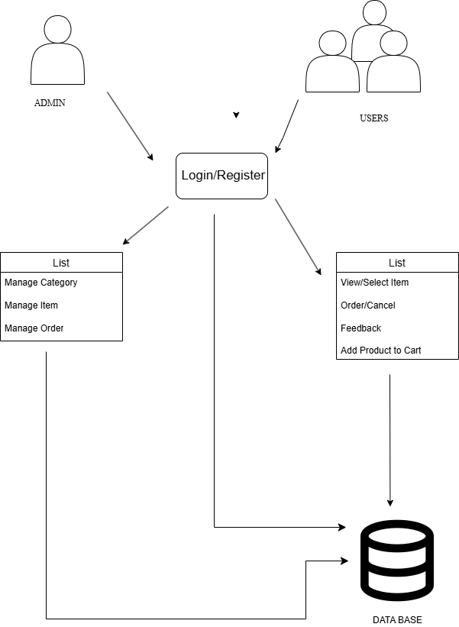

**Figure 3.1** System Architecture

Category Management:

* Allow administrators to create, update, and delete product categories.
* Associate products with appropriate categories to facilitate navigation.
* Display category images and descriptions to enhance user experience.

Security and Privacy:

* Implement SSL encryption to secure data transmission between the client and server.
* Use authentication and authorization mechanisms to control access to sensitive information.

Scalability and Performance:

* Design the database schema for scalability to accommodate growth in data volume and user traffic.
* Optimize database queries and indexing for efficient data retrieval.

**Workflow:**

Frontend (User Interaction Layer):User -> Homepage/Search -> Product Page -> Add o Cart -> Checkout -> Order Confirmation

Backend (Application Logic Layer):Database Updates -> Inventory Management -> Order Processing -> Payment Processing -> CRM Updates -> Shipping Coordination

Admin Panel:Product Management -> Inventory Monitoring -> Order Tracking -> Customer Support -> Analytics Review

**For Admin:**

Product Management

* Database Updates: Administrators add or update book listings, descriptions, prices, and stock levels in the database.
* Category Management: Categories and genres are managed to ensure easy navigation for users.

Inventory Management

* Stock Monitoring: Real-time monitoring of inventory levels to prevent stockouts and overstocking.
* Reordering: Automated or manual reordering of books from suppliers based on inventory levels.

Order Management

* Order Tracking: Monitoring order statuses from placement to delivery.
* Customer Notifications: Automated notifications for order confirmations, shipping, and delivery.

Analytics and Reporting

* Sales Data: Analyzing sales data to identify trends and performance metrics.
* Customer Behavior: Tracking customer behavior to optimize the shopping experience.

# For Customer:

# User Browsing

# Homepage: Users land on the homepage where they see featured books, promotions, and categories.

# Product Pages: Clicking on a book leads to a detailed product page with book descriptions, reviews, author information, and purchase options.

# Product Selection

# Adding to Cart: Users select desired books and add them to their shopping cart.

# Wishlist: Users can also add books to their wishlist for future purchases.

# Checkout Process

# Sign-In/Register: Users log in to their account or create a new one.

# Order Review: Users review their order details.

# 3.2 Sequence Diagram

# 

# Figure 3.2 Sequence Diagram

# Figure 3.2 This diagram represents a sequence diagram for an e-commerce website, illustrating the interactions between a customer and various components of the e-commerce system during the purchasing process.

# 

# 4.IMPLEMENTATION

# Implementing an e-commerce website for an online bookstore involves several key steps, from planning and design to development and deployment, and here are the following steps are discussed below:

# Planning and Requirement Analysis

# Define Objectives: Establish the primary goals of your online bookstore (e.g., selling books, providing book reviews, etc.).

# Target Audience: Identify your target audience and their preferences.

# Market Research: Analyze competitors and market trends to understand what works and what doesn’t.

# Design

# User Interface (UI): Design a user-friendly and aesthetically pleasing interface. Key pages include the homepage, product pages, shopping cart, and checkout page.

# User Experience (UX): Ensure easy navigation, fast load times, and a seamless shopping experience.

# Technology Stack

# Front-End:HTML, CSS, JavaScript for basic structure and styling.

# Front-end frameworks/libraries like React, Angular, or Vue.js for dynamic content.

# Back-End:Server-side languages like Node.js, Python (Django or Flask), Ruby on Rails, or PHP.

# Frameworks like Express.js (for Node.js), Django (for Python), or Laravel (for PHP).

# Database:SQL databases like MySQL, PostgreSQL.

# NoSQL databases like MongoDB for flexibility in data storage.

# Hosting:Cloud services like AWS, Google Cloud, or Azure.

# Web hosting services like Bluehost, SiteGround, or DigitalOcean.

# 

# Features

# User Authentication: Implement user registration, login, and password recovery features.

# Product Catalog: Display a list of books with details like title, author, price, and reviews.

# Search and Filters: Allow users to search for books and filter results by categories, price, ratings, etc.

# Product Pages: Detailed book pages with descriptions, reviews, ratings, and related books.

# Shopping Cart: Enable users to add books to a shopping cart, view cart contents, and update quantities.

# Checkout Process: Implement a streamlined checkout process with payment gateway integration (e.g., Stripe, PayPal).

# Order Management: Allow users to view their order history and track orders.

# Admin Panel: For managing books, categories, orders, users, and site content.

# 5.RESULTS

**5.1 Login page**

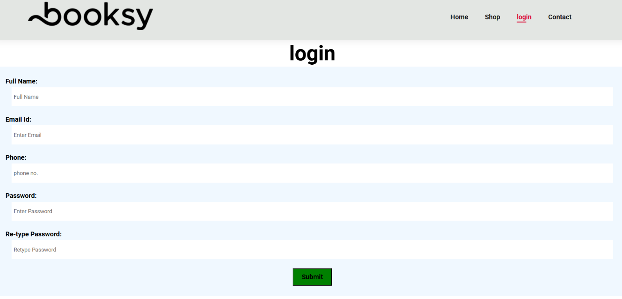

**Figure 5.1** LOGIN PAGE

Figure 5.1 shows the login page which provides security for the system. The one who knows the username and password are only allowed to access the details. The fields are validated. Once the Login button is pressed with correct details,it will display a dialog box showing a welcome message. Once the Ok button is pressed it will redirect you to the home page. If wrong details are entered it shows a wrong credentials message in the dialog box.

**5.2 Home Page**

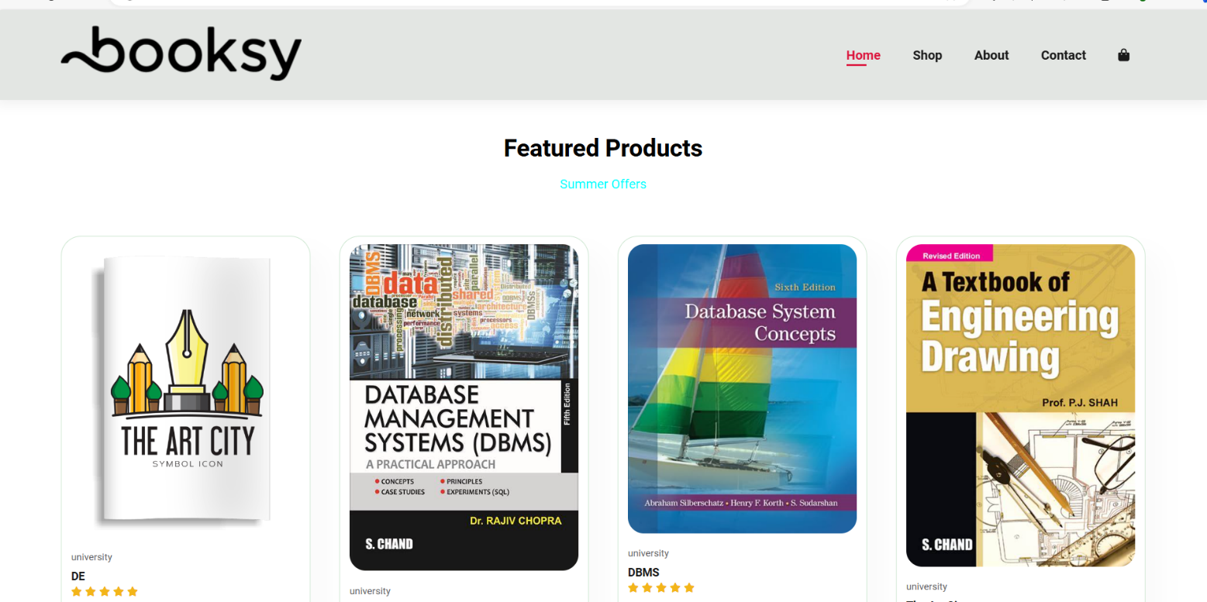

**Figure 5.2** HOME PAGE

Figure 5.2 The home page features a clean design with a header containing the logo and navigation options Home, Shop, About, Contact, and a user account icon. Below, a Featured Products section highlights Summer Offers

5.3 SHOPPING PAGE

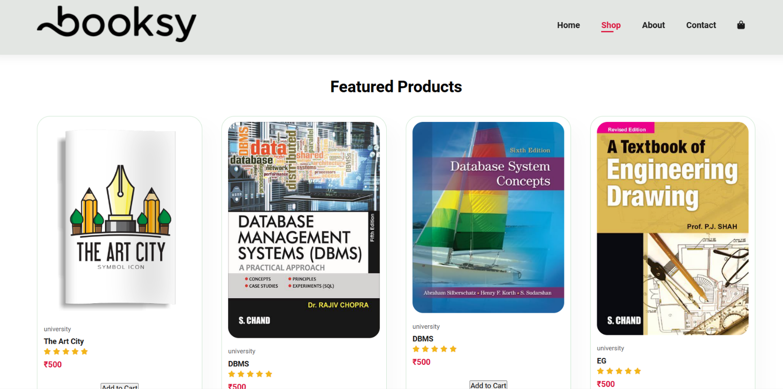

**Figure 5.3** SHOPPING PAGE

Figure 5.3 It illustrates a clean and intuitive layout designed to enhance the user experience. The top header includes the logo on the left and navigation options on the right—Home, Shop highlighted to indicate the current page, About, and Contact—along with a user account icon. Directly below the header, the Featured Products section showcases a selection of books, each presented with a cover image, title, author or publisher information, a university tag, and a star rating.

5.4 CART PAGE

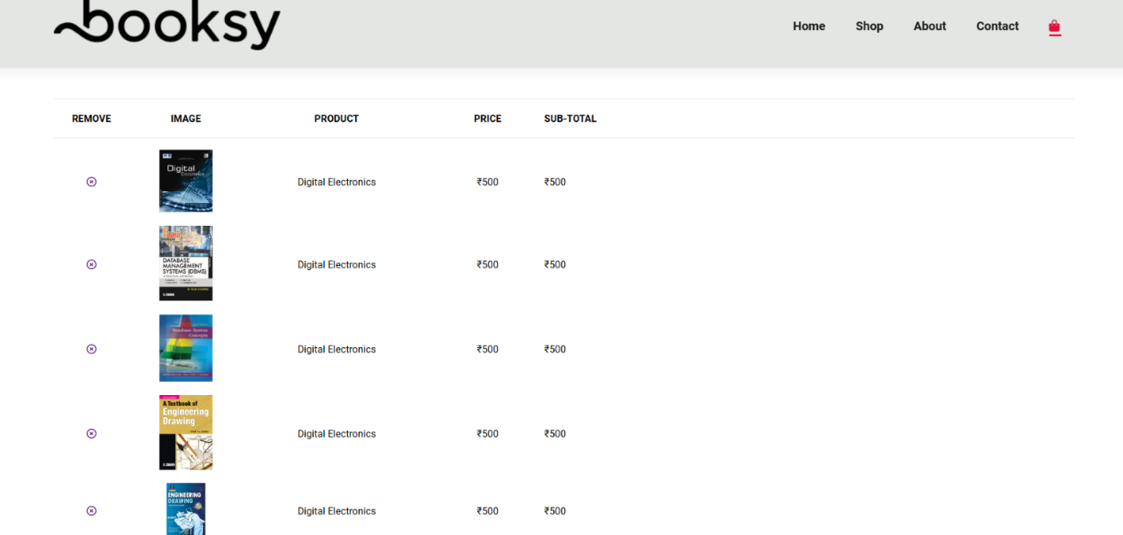

**Figure 5.4** CART PAGE

Figure 5.4 The cart page provides a summary of selected items before checkout. It features the store's logo and navigation options at the top. The main section lists the books added to the cart, including thumbnails, titles, authors, quantities, individual prices, and total prices. Users can adjust quantities or remove items. Below the list, the subtotal, taxes, shipping fees, and the total amount due are displayed. The page includes Proceed to Checkout and Continue Shopping buttons, facilitating easy review and adjustment of selections

# 6.CONCLUSION AND FUTURE SCOPE

# 6.1 CONCLUSION

E-commerce websites for books have revolutionized the way readers discover, purchase, and enjoy literature. By leveraging advanced technologies such as secure payment gateways, real-time inventory management, and personalized customer experiences, these platforms provide convenience and accessibility to a vast selection of books from anywhere in the world. Effective integration of CRM and analytics allows for targeted marketing, enhancing customer satisfaction and loyalty. Despite the challenges related to security and logistics, e-commerce book platforms have proven to be resilient and adaptable, continuously evolving to meet the demands of a dynamic market.

# 6.2 FUTURE SCOPE

The future scope of e-commerce websites for books is vast and promising, driven by technological advancements and evolving consumer preferences. Integrating AI and machine learning will further personalize recommendations and enhance customer engagement. Voice search and augmented reality (AR) can improve accessibility and user experience, while sustainability initiatives like eco-friendly packaging and expanded digital and audiobook catalogs address environmental concerns. Global reach can be enhanced through localization, offering multilingual and multicurrency support, and improving international shipping logistics. Blockchain technology can secure transactions and verify the authenticity of rare books, while advanced analytics and IoT can optimize inventory management and provide deeper customer insights. Enhanced security measures, such as biometric authentication and AI-driven fraud detection, will protect user data and transactions. These innovations will ensure e-commerce book platforms remain competitive, catering to a global audience and fostering a richer reading experience in the digital age.

# BIBILOGRAPHY

# [1] Manju Khari , “IoT in retail and e-commerce: A Comprehensive Review”, 10660-023-09785-3,2023

# [2] Jian Ren et.al, “E-commerce Research and Applications ”, Vol. 3, No. 3, 2004, pp 294-310

[3] Randy C. Marchany Joseph G. Tront, “ E-commerce Security Issues”, 10.11.08/HICSS .2002.1194190

**APPENDIX**

**Index.html**

<!DOCTYPE html>

<html lang="en">

<head>

<meta charset="UTF-8">

<meta http-equiv="X-UA-Compatible" content="IE=edge">

<meta name="viewport" content="width=device-width, initial-scale=1.0">

<title> Ecommerce website</title>

<link rel="stylesheet" href="https://cdnjs.cloudflare.com/ajax/libs/font-awesome/6.5.2/css/all.min.css">

<link rel="stylesheet" href="style.css">

</head>

<body>

<section id="header">

<a href="#"><img src="img/logo.png" class="logo" alt=""></a>

<div>

<ul id="navbar">

<li><a class="active" href="index.html">Home</a></li>

<li><a href="shop.html">Shop</a></li>

<li><a href="login.html">login</a></li>

<li><a href="contact.html">Contact</a></li>

<li><a href="cart.html"><i class="fa fa-shopping-bag" aria-hidden="true"></i></a></li>

</ul>

</div>

</section>

<section id="product1" class="section-p1">

<h2>Featured Products</h2>

<p> Summer Offers</p>

<div class="pro-container">

<div class="pro" onclick="window.location.href='sproduct.html'">

<img src="img/book-1.png" alt="">

<div class="des">

<span>university</span>

<h5>DE</h5>

<div class="star">

<i class="fas fa-star"></i>

<i class="fas fa-star"></i>

<i class="fas fa-star"></i>

<i class="fas fa-star"></i>

<i class="fas fa-star"></i>

</div>

<h4>₹500</h4>

</div>

</div>

<div class="pro" onclick="window.location.href='sproduct2.html'">

<img src="img/book-12.jpeg" alt="">

<div class="des">

<span>university</span>

<h5>DBMS</h5>

<div class="star">

<i class="fas fa-star"></i>

<i class="fas fa-star"></i>

<i class="fas fa-star"></i>

<i class="fas fa-star"></i>

<i class="fas fa-star"></i>

</div>

<h4>₹500</h4>

</div>

</div>

<div class="pro" onclick="window.location.href='sproduct3.html'">

<img src="img/book-13.jpg" alt="">

<div class="des">

<span>university</span>

<h5>DBMS</h5>

<div class="star">

<i class="fas fa-star"></i>

<i class="fas fa-star"></i>

<i class="fas fa-star"></i>

<i class="fas fa-star"></i>

<i class="fas fa-star"></i>

</div>

<h4>₹500</h4>

</div>

</div>

<div class="pro" onclick="window.location.href='sproduct14.html'">

<img src="img/book-14.jpeg" alt="">

<div class="des">

<span>university</span>

<h5>The Art City</h5>

<div class="star">

<i class="fas fa-star"></i>

<i class="fas fa-star"></i>

<i class="fas fa-star"></i>

<i class="fas fa-star"></i>

<i class="fas fa-star"></i>

</div>

<h4>₹500</h4>

</div>

<p><button>Add to Cart</button></p>

</div>

<div class="pro" onclick="window.location.href='sproduct5.html'">

<img src="img/book-5.png" alt="">

<div class="des">

<span>university</span>

<h5>The Art City</h5>

<div class="star">

<i class="fas fa-star"></i>

<i class="fas fa-star"></i>

<i class="fas fa-star"></i>

<i class="fas fa-star"></i>

<i class="fas fa-star"></i>

</div>

<h4>₹500</h4>

</div>

<p><button>Add to Cart</button></p>

</div>

<div class="pro" onclick="window.location.href='sproduct6.html'">

<img src="img/book-6.png" alt="">

<div class="des">

<span>university</span>

<h5>The Art City</h5>

<div class="star">

<i class="fas fa-star"></i>

<i class="fas fa-star"></i>

<i class="fas fa-star"></i>

<i class="fas fa-star"></i>

<i class="fas fa-star"></i>

</div>

<h4>₹500</h4>

</div>

<p><button>Add to Cart</button></p>

</div>

<div class="pro" onclick="window.location.href='sproduct7.html'">

<img src="img/book-7.png" alt="">

<div class="des">

<span>university</span>

<h5>The Art City</h5>

<div class="star">

<i class="fas fa-star"></i>

<i class="fas fa-star"></i>

<i class="fas fa-star"></i>

<i class="fas fa-star"></i>

<i class="fas fa-star"></i>

</div>

<h4>₹500</h4>

</div>

<p><button>Add to Cart</button></p>

</div>

<div class="pro" onclick="window.location.href='sproduct9.html'">

<img src="img/book-8.png" alt="">

<div class="des">

<span>university</span>

<h5>The Art City</h5>

<div class="star">

<i class="fas fa-star"></i>

<i class="fas fa-star"></i>

<i class="fas fa-star"></i>

<i class="fas fa-star"></i>

<i class="fas fa-star"></i>

</div>

<h4>₹500</h4>

</div>

<p><button>Add to Cart</button></p>

</div>

</div>

</div>

</section>

<section id="product1" class="section-p1">

<h2>Featured Products</h2>

<p> Summer Offers</p>

<div class="pro-container">

<div class="pro" onclick="window.location.href='sproduct9.html'">

<img src="img/book-9.png" alt="">

<div class="des">

<span>university</span>

<h5>The Art City</h5>

<div class="star">

<i class="fas fa-star"></i>

<i class="fas fa-star"></i>

<i class="fas fa-star"></i>

<i class="fas fa-star"></i>

<i class="fas fa-star"></i>

</div>

<h4>₹500</h4>

</div>

<p><button>Add to Cart</button></p>

</div>

<div class="pro" onclick="window.location.href='sproduct10.html'">

<img src="img/book-10.png" alt="">

<div class="des">

<span>university</span>

<h5>The Art City</h5>

<div class="star">

<i class="fas fa-star"></i>

<i class="fas fa-star"></i>

<i class="fas fa-star"></i>

<i class="fas fa-star"></i>

<i class="fas fa-star"></i>

</div>

<h4>₹500</h4>

</div>

<p><button>Add to Cart</button></p>

</div>

<div class="pro" onclick="window.location.href='sproduct3.html'">

<img src="img/book-3.png" alt="">

<div class="des">

<span>university</span>

<h5>The Art City</h5>

<div class="star">

<i class="fas fa-star"></i>

<i class="fas fa-star"></i>

<i class="fas fa-star"></i>

<i class="fas fa-star"></i>

<i class="fas fa-star"></i>

</div>

<h4>₹500</h4>

</div>

<p><button>Add to Cart</button></p>

</div>

<div class="pro" onclick="window.location.href='sproduct4.html'">

<img src="img/book-4.png" alt="">

<div class="des">

<span>university</span>

<h5>The Art City</h5>

<div class="star">

<i class="fas fa-star"></i>

<i class="fas fa-star"></i>

<i class="fas fa-star"></i>

<i class="fas fa-star"></i>

<i class="fas fa-star"></i>

</div>

<h4>₹500</h4>

</div>

<p><button>Add to Cart</button></p>

</div>

<div class="pro" onclick="window.location.href='sproduct5.html'">

<img src="img/book-5.png" alt="">

<div class="des">

<span>university</span>

<h5></h5>

<div class="star">

<i class="fas fa-star"></i>

<i class="fas fa-star"></i>

<i class="fas fa-star"></i>

<i class="fas fa-star"></i>

<i class="fas fa-star"></i>

</div>

<h4>₹500</h4>

</div>

</div>

<div class="pro" onclick="window.location.href='sproduct6.html'">

<img src="img/book-6.png" alt="">

<div class="des">

<span>university</span>

<h5></h5>

<div class="star">

<i class="fas fa-star"></i>

<i class="fas fa-star"></i>

<i class="fas fa-star"></i>

<i class="fas fa-star"></i>

<i class="fas fa-star"></i>

</div>

<h4>₹500</h4>

</div>

</div>

<div class="pro" onclick="window.location.href='sproduct7.html'">

<img src="img/book-7.png" alt="">

<div class="des">

<span>university</span>

<h5></h5>

<div class="star">

<i class="fas fa-star"></i>

<i class="fas fa-star"></i>

<i class="fas fa-star"></i>

<i class="fas fa-star"></i>

<i class="fas fa-star"></i>

</div>

<h4>₹500</h4>

</div>

</div>

<div class="pro" onclick="window.location.href='sproduct8.html'">

<img src="img/book-8.png" alt="">

<div class="des">

<span>university</span>

<h5></h5>

<div class="star">

<i class="fas fa-star"></i>

<i class="fas fa-star"></i>

<i class="fas fa-star"></i>

<i class="fas fa-star"></i>

<i class="fas fa-star"></i>

</div>

<h4>₹500</h4>

</div>

</div>

</div>

</div>

</section>

<footer Class="section-p1">

<div class="col">

<h4>Contact</h4>

<p><strong>Address: </strong> koti,street 12,Hyderabad</p>

<p><strong>Phone:</strong>+912222356784/ +910123456789</p>

<p><strong>Hours:</strong>9:00-10:00, Mon-Sat</p>

<div class="follow">

<h4>Follow Us</h4>

<div class="icon">

<i class="fab fa-facebook"></i>

<i class="fab fa-instagram"></i>

<i class="fab fa-twitter"></i>

<i class="fab fa-youtube"></i>

</div>

</div>

</div>

<div class="col">

<h4>About Us</h4>

<a href="#">About Us</a>

<a href="#">Delivery Information</a>

<a href="#">Privacy Policy</a>

<a href="#">Terms & Conditions</a>

<a href="#">Contact Us</a>

</div>

<div class="col">

<h4>My Account</h4>

<a href="#">Sign In</a>

<a href="#">View Cart</a>

<a href="#">My Wishlist</a>

<a href="#">Track My Order</a>

<a href="#">Help</a>

</div>

<div class="copyright">

<p> E-commerce Website </p>

</div>

</footer>

<script src="script.js"></script>

</body>

</html>

Shop.html

<!DOCTYPE html>

<html lang="en">

<head>

<meta charset="UTF-8">

<meta http-equiv="X-UA-Compatible" content="IE=edge">

<meta name="viewport" content="width=device-width, initial-scale=1.0">

<title> Ecommerce website</title>

<link rel="stylesheet" href="https://cdnjs.cloudflare.com/ajax/libs/font-awesome/6.5.2/css/all.min.css">

<link rel="stylesheet" href="style.css">

</head>

<body>

<section id="header">

<a href="#"><img src="img/logo.png" class="logo" alt=""></a>

<div>

<ul id="navbar">

<li><a href="index.html">Home</a></li>

<li><a class="active" href="shop.html">Shop</a></li>

<li><a href="about.html">About</a></li>

<li><a href="contact.html">Contact</a></li>

<li><a href="cart.html"><i class="fa fa-shopping-bag" aria-hidden="true"></i></a></li>

</ul>

</div>

</section>

<section id="product1" class="section-p1">

<h2>Featured Products</h2>

<div class="pro-container">

<div class="pro" onclick="window.location.href='sproduct.html'">

<img src="img/book-1.png" alt="">

<div class="des">

<span>university</span>

<h5>The Art City</h5>

<div class="star">

<i class="fas fa-star"></i>

<i class="fas fa-star"></i>

<i class="fas fa-star"></i>

<i class="fas fa-star"></i>

<i class="fas fa-star"></i>

</div>

<h4>₹500</h4>

</div>

<p><button>Add to Cart</button></p>

</div>

<div class="pro" onclick="window.location.href='sproduct2.html'">

<img src="img/book-12.jpeg" alt="">

<div class="des">

<span>university</span>

<h5>DBMS</h5>

<div class="star">

<i class="fas fa-star"></i>

<i class="fas fa-star"></i>

<i class="fas fa-star"></i>

<i class="fas fa-star"></i>

<i class="fas fa-star"></i>

</div>

<h4>₹500</h4>

</div>

<p><button>Add to Cart</button></p>

</div>

<div class="pro" onclick="window.location.href='sproduct3.html'">

<img src="img/book-13.jpg" alt="">

<div class="des">

<span>university</span>

<h5>DBMS</h5>

<div class="star">

<i class="fas fa-star"></i>

<i class="fas fa-star"></i>

<i class="fas fa-star"></i>

<i class="fas fa-star"></i>

<i class="fas fa-star"></i>

</div>

<h4>₹500</h4>

</div>

<p><button>Add to Cart</button></p>

</div>

<div class="pro" onclick="window.location.href='sproduct4.html'">

<img src="img/book-14.jpeg" alt="">

<div class="des">

<span>university</span>

<h5>EG</h5>

<div class="star">

<i class="fas fa-star"></i>

<i class="fas fa-star"></i>

<i class="fas fa-star"></i>

<i class="fas fa-star"></i>

<i class="fas fa-star"></i>

</div>

<h4>₹500</h4>

</div>

<p><button>Add to Cart</button></p>

</div>

<div class="pro" onclick="window.location.href='sproduct5.html'">

<img src="img/book-5.png" alt="">

<div class="des">

<span>university</span>

<h5>The Art City</h5>

<div class="star">

<i class="fas fa-star"></i>

<i class="fas fa-star"></i>

<i class="fas fa-star"></i>

<i class="fas fa-star"></i>

<i class="fas fa-star"></i>

</div>

<h4>₹500</h4>

</div>

<p><button>Add to Cart</button></p>

</div>

<div class="pro" onclick="window.location.href='sproduct6.html'">

<img src="img/book-6.png" alt="">

<div class="des">

<span>university</span>

<h5>The Art City</h5>

<div class="star">

<i class="fas fa-star"></i>

<i class="fas fa-star"></i>

<i class="fas fa-star"></i>

<i class="fas fa-star"></i>

<i class="fas fa-star"></i>

</div>

<h4>₹500</h4>

</div>

<p><button>Add to Cart</button></p>

</div>

<div class="pro" onclick="window.location.href='sproduct7.html'">

<img src="img/book-7.png" alt="">

<div class="des">

<span>university</span>

<h5>The Art City</h5>

<div class="star">

<i class="fas fa-star"></i>

<i class="fas fa-star"></i>

<i class="fas fa-star"></i>

<i class="fas fa-star"></i>

<i class="fas fa-star"></i>

</div>

<h4>₹500</h4>

</div>

<p><button>Add to Cart</button></p>

</div>

<div class="pro" onclick="window.location.href='sproduct8.html'">

<img src="img/book-8.png" alt="">

<div class="des">

<span>university</span>

<h5>The Art City</h5>

<div class="star">

<i class="fas fa-star"></i>

<i class="fas fa-star"></i>

<i class="fas fa-star"></i>

<i class="fas fa-star"></i>

<i class="fas fa-star"></i>

</div>

<h4>₹500</h4>

</div>

<p><button>Add to Cart</button></p>

</div>

</div>

</div>

<div class="pro-container">

<div class="pro" onclick="window.location.href='sproduct9.html'">

<img src="img/book-9.png" alt="">

<div class="des">

<span>university</span>

<h5>The Art City</h5>

<div class="star">

<i class="fas fa-star"></i>

<i class="fas fa-star"></i>

<i class="fas fa-star"></i>

<i class="fas fa-star"></i>

<i class="fas fa-star"></i>

</div>

<h4>₹500</h4>

</div>

<p><button>Add to Cart</button></p>

</div>

<div class="pro" onclick="window.location.href='sproduct10.html'">

<img src="img/book-10.png" alt="">

<div class="des">

<span>university</span>

<h5>The Art City</h5>

<div class="star">

<i class="fas fa-star"></i>

<i class="fas fa-star"></i>

<i class="fas fa-star"></i>

<i class="fas fa-star"></i>

<i class="fas fa-star"></i>

</div>

<h4>₹500</h4>

</div>

<p><button>Add to Cart</button></p>

</div>

<div class="pro" onclick="window.location.href='sproduct3.html'">

<img src="img/book-3.png" alt="">

<div class="des">

<span>university</span>

<h5>The Art City</h5>

<div class="star">

<i class="fas fa-star"></i>

<i class="fas fa-star"></i>

<i class="fas fa-star"></i>

<i class="fas fa-star"></i>

<i class="fas fa-star"></i>

</div>

<h4>₹500</h4>

</div>

<p><button>Add to Cart</button></p>

</div>

<div class="pro" onclick="window.location.href='sproduct4.html'">

<img src="img/book-4.png" alt="">

<div class="des">

<span>university</span>

<h5>The Art City</h5>

<div class="star">

<i class="fas fa-star"></i>

<i class="fas fa-star"></i>

<i class="fas fa-star"></i>

<i class="fas fa-star"></i>

<i class="fas fa-star"></i>

</div>

<h4>₹500</h4>

</div>

<p><button>Add to Cart</button></p>

</div>

<div class="pro" onclick="window.location.href='sproduct5.html'">

<img src="img/book-5.png" alt="">

<div class="des">

<span>university</span>

<h5>The Art City</h5>

<div class="star">

<i class="fas fa-star"></i>

<i class="fas fa-star"></i>

<i class="fas fa-star"></i>

<i class="fas fa-star"></i>

<i class="fas fa-star"></i>

</div>

<h4>₹500</h4>

</div>

<p><button>Add to Cart</button></p>

</div>

<div class="pro" onclick="window.location.href='sproduct6.html'">

<img src="img/book-6.png" alt="">

<div class="des">

<span>university</span>

<h5>The Art City</h5>

<div class="star">

<i class="fas fa-star"></i>

<i class="fas fa-star"></i>

<i class="fas fa-star"></i>

<i class="fas fa-star"></i>

<i class="fas fa-star"></i>

</div>

<h4>₹500</h4>

</div>

<p><button>Add to Cart</button></p>

</div>

<div class="pro" onclick="window.location.href='sproduct7.html'">

<img src="img/book-7.png" alt="">

<div class="des">

<span>university</span>

<h5>The Art City</h5>

<div class="star">

<i class="fas fa-star"></i>

<i class="fas fa-star"></i>

<i class="fas fa-star"></i>

<i class="fas fa-star"></i>

<i class="fas fa-star"></i>

</div>

<h4>₹500</h4>

</div>

<p><button>Add to Cart</button></p>

</div>

<div class="pro" onclick="window.location.href='sproduct8.html'">

<img src="img/book-8.png" alt="">

<div class="des">

<span>university</span>

<h5>The Art City</h5>

<div class="star">

<i class="fas fa-star"></i>

<i class="fas fa-star"></i>

<i class="fas fa-star"></i>

<i class="fas fa-star"></i>

<i class="fas fa-star"></i>

</div>

<h4>₹500</h4>

</div>

<p><button>Add to Cart</button></p>

</div>

</div>

</div>

</section>

<section id="pagination" class="section-p1">

<a href="#">1</a>

<a href="#">2</a>

<a href="#"><i class="fa fa-long-arrow-alt-right"></i></a>

</section>

<footer Class="section-p1">

<div class="col">

<h4>Contact</h4>

<p><strong>Address: </strong> koti,street 12,Hyderabad</p>

<p><strong>Phone:</strong>+912222356784/ +910123456789</p>

<p><strong>Hours:</strong>9:00-10:00, Mon-Sat</p>

<div class="follow">

<h4>Follow Us</h4>

<div class="icon">

<i class="fab fa-facebook"></i>

<i class="fab fa-instagram"></i>

<i class="fab fa-twitter"></i>

<i class="fab fa-youtube"></i>

</div>

</div>

</div>

<div class="col">

<h4>About Us</h4>

<a href="#">About Us</a>

<a href="#">Delivery Information</a>

<a href="#">Privacy Policy</a>

<a href="#">Terms & Conditions</a>

<a href="#">Contact Us</a>

</div>

<div class="col">

<h4>My Account</h4>

<a href="#">Sign In</a>

<a href="#">View Cart</a>

<a href="#">My Wishlist</a>

<a href="#">Track My Order</a>

<a href="#">Help</a>

</div>

<div class="copyright">

<p> E-commerce Website </p>

</div>

</footer>

<script src="script.js"></script>

</body>

</html>

Login.html

<!DOCTYPE html>

<html>

<head>

<title>Ecommerce website</title>

<meta charset="UTF-8">

<meta name="viewport" content="width=device-width, initial-scale=1">

<link rel="stylesheet" href="style.css">

<style>

input[type=text], input[type=password], textarea, select {

width: 98%;

padding: 15px 5px;

margin: 5px 0 22px 0;

display: inline-block;

border: none;

}

input[type=text]:focus, input[type=password]:focus {

outline: none;

}

.text-center{

text-align: center;

}

.float-left{

float: left;

}

.registerbtn{

background: green;

padding: 10px 20px;

font-size: 16px;

font-weight: bold;

}

.registerbtn:hover{

background: #f1f1f1;

padding: 10px 20px;

font-size: 16px;

font-weight: bold;

}

.w-100{

width: 100%;

padding: 25px;

background: aliceblue;

}

</style>

</head>

<body>

<section id="header">

<a href="#"><img src="img/logo.png" class="logo" alt=""></a>

<div>

<ul id="navbar">

<li><a href="index.html">Home</a></li>

<li><a href="shop.html">Shop</a></li>

<li><a class="active" href="login.html">login</a></li>

<li><a href="contact.html">Contact</a></li>

<li><a href="cart.html"><i class="fa fa-shopping-bag" aria-hidden="true"></i></a></li>

</ul>

</div>

</section>

<div class="page-content text-center">

<h1 class="main-title">login</h1>

<form>

<div class="w-100">

<label class="float-left"> <b>Full Name:</b> </label>

<input type="text" id="full_name" placeholder="Full Name" size="15" />

<label class="float-left" for="email"><b>Email Id:</b></label>

<input type="text" placeholder="Enter Email" id="email" required />

<label class="float-left"><b>Phone:</b></label>

<input type="text" id="phone" placeholder="phone no." size="10" required />

<label class="float-left" for="psw"><b>Password:</b></label>

<input type="password" placeholder="Enter Password" id="pwd" required />

<label class="float-left" for="psw-repeat"><b>Re-type Password:</b></label>

<input type="password" placeholder="Retype Password" id="cpwd" required />

<button type="submit" class="registerbtn">Submit</button>

</div>

</form>

</div>

</body>

</html>

Contact.html

<!DOCTYPE html>

<html lang="en">

<head>

<meta charset="UTF-8">

<meta http-equiv="X-UA-Compatible" content="IE=edge">

<meta name="viewport" content="width=device-width, initial-scale=1.0">

<title> Ecommerce website</title>

<link rel="stylesheet" href="https://cdnjs.cloudflare.com/ajax/libs/font-awesome/6.5.2/css/all.min.css">

<link rel="stylesheet" href="style.css">

</head>

<body>

<section id="header">

<a href="#"><img src="img/logo.png" class="logo" alt=""></a>

<div>

<ul id="navbar">

<li><a href="index.html">Home</a></li>

<li><a href="shop.html">Shop</a></li>

<li><a href="login.html">login</a></li>

<li><a class="active" href="contact.html">Contact</a></li>

<li><a href="cart.html"><i class="fa fa-shopping-bag" aria-hidden="true"></i></a></li>

</ul>

</div>

</section>

<section id="contact-details" class="section-p1">

<div class="details">

<span>GET IN TOUCH</span>

<h2>Visit one of our locations or contact us today</h2>

<h3>Head Office</h3>

<div>

<li>

<i class="fal fa-map"></i>

<p>koti street pillar number B1201</p>

</li>

<li>

<i class="fa fa-email"></i>

<p>contact@example.com</p>

</li>

<li>

<p>monday to saturday: 9:00am to 4:00pm</p>

</li>

</div>

</div>

<div class="map">

<iframe src="https://www.google.com/maps/embed?pb=!1m18!1m12!1m3!1d121812.83806352582!2d78.25307687840612!3d17.4285194025236!2m3!1f0!2f0!3f0!3m2!1i1024!2i768!4f13.1!3m3!1m2!1s0x3bcb99d26a746d77%3A0x82c92de12686d614!2sBooks%20N%20Books!5e0!3m2!1sen!2sin!4v1717734719064!5m2!1sen!2sin" width="600" height="450" style="border:0;" allowfullscreen="" loading="lazy" referrerpolicy="no-referrer-when-downgrade"></iframe>

</div>

</section>

<section id="form-details">

<form action="">

<span>LEAVE A MESSAGE</span>

<h2>We love to hear from you</h2>

<input type="text" placeholder="Your Name">

<input type="text" placeholder="E-mail">

<input type="text" placeholder="Subject">

<textarea name="" id="" cols="30" rows="10" placeholder="Your Message"></textarea>

<button class="normal">Submit</button>

</form>

</section>

<footer Class="section-p1">

<div class="col">

<h4>Contact</h4>

<p><strong>Address: </strong> koti,street 12,Hyderabad</p>

<p><strong>Phone:</strong>+912222356784/ +910123456789</p>

<p><strong>Hours:</strong>9:00-10:00, Mon-Sat</p>

<div class="follow">

<h4>Follow Us</h4>

<div class="icon">

<i class="fab fa-facebook"></i>

<i class="fab fa-instagram"></i>

<i class="fab fa-twitter"></i>

<i class="fab fa-youtube"></i>

</div>

</div>

</div>

<div class="col">

<h4>About Us</h4>

<a href="#">About Us</a>

<a href="#">Delivery Information</a>

<a href="#">Privacy Policy</a>

<a href="#">Terms & Conditions</a>

<a href="#">Contact Us</a>

</div>

<div class="col">

<h4>My Account</h4>

<a href="#">Sign In</a>

<a href="#">View Cart</a>

<a href="#">My Wishlist</a>

<a href="#">Track My Order</a>

<a href="#">Help</a>

</div>

<div class="copyright">

<p> E-commerce Website </p>

</div>

</footer>

<script src="script.js"></script>

</body>

</html>

Cart.html

<!DOCTYPE html>

<html lang="en">

<head>

<meta charset="UTF-8">

<meta http-equiv="X-UA-Compatible" content="IE=edge">

<meta name="viewport" content="width=device-width, initial-scale=1.0">

<title> Ecommerce website</title>

<link rel="stylesheet" href="https://cdnjs.cloudflare.com/ajax/libs/font-awesome/6.5.2/css/all.min.css">

<link rel="stylesheet" href="style.css">

</head>

<body>

<section id="header">

<a href="#"><img src="img/logo.png" class="logo" alt=""></a>

<div>

<ul id="navbar">

<li><a href="index.html">Home</a></li>

<li><a href="shop.html">Shop</a></li>

<li><a href="login.html">login</a></li>

<li><a href="contact.html">Contact</a></li>

<li><a class="active" href="cart.html"><i class="fa fa-shopping-bag" aria-hidden="true"></i></a></li>

</ul>

</div>

</section>

<section id="cart" class="section-p1">

<table width="100%">

<thead>

<tr>

<td>Remove</td>

<td>Image</td>

<td>Product</td>

<td>Price</td>

<td>Sub-Total</td>

</tr>

</thead>

<tbody>

<tr>

<td><a href="#"><i class="far fa-times-circle"></i></a></td>

<td><img src="img/book-11.jpg" alt=""></td>

<td>Digital Electronics</td>

<td>₹500</td>

<td>₹500</td>

</tr>

<tr>

<td><a href="#"><i class="far fa-times-circle"></i></a></td>

<td><img src="img/book-12.jpeg" alt=""></td>

<td>Digital Electronics</td>

<td>₹500</td>

<td>₹500</td>

</tr>

<tr>

<td><a href="#"><i class="far fa-times-circle"></i></a></td>

<td><img src="img/book-13.jpg" alt=""></td>

<td>Digital Electronics</td>

<td>₹500</td>

<td>₹500</td>

</tr>

<tr>

<td><a href="#"><i class="far fa-times-circle"></i></a></td>

<td><img src="img/book-14.jpeg" alt=""></td>

<td>Digital Electronics</td>

<td>₹500</td>

<td>₹500</td>

</tr>

<tr>

<td><a href="#"><i class="far fa-times-circle"></i></a></td>

<td><img src="img/book-15.jpg" alt=""></td>

<td>Digital Electronics</td>

<td>₹500</td>

<td>₹500</td>

</tr>

</tbody>

</table>

</section>

<footer Class="section-p1">

<div class="col">

<h4>Contact</h4>

<p><strong>Address: </strong> koti,street 12,Hyderabad</p>

<p><strong>Phone:</strong>+912222356784/ +910123456789</p>

<p><strong>Hours:</strong>9:00-10:00, Mon-Sat</p>

<div class="follow">

<h4>Follow Us</h4>

<div class="icon">

<i class="fab fa-facebook"></i>

<i class="fab fa-instagram"></i>

<i class="fab fa-twitter"></i>

<i class="fab fa-youtube"></i>

</div>

</div>

</div>

<div class="col">

<h4>About Us</h4>

<a href="#">About Us</a>

<a href="#">Delivery Information</a>

<a href="#">Privacy Policy</a>

<a href="#">Terms & Conditions</a>

<a href="#">Contact Us</a>

</div>

<div class="col">

<h4>My Account</h4>

<a href="#">Sign In</a>

<a href="#">View Cart</a>

<a href="#">My Wishlist</a>

<a href="#">Track My Order</a>

<a href="#">Help</a>

</div>

<div class="copyright">

<p> E-commerce Website </p>

</div>

</footer>

<script src="script.js"></script>

</body>

</html>

Main.css

@import url('https://fonts.googleapis.com/css2?family=Roboto:ital,wght@0,100;0,300;0,400;0,500;0,700;0,900;1,100;1,300;1,400;1,500;1,700;1,900&display=swap');

*{

margin:0;

padding: 0;

box-sizing: border-box;

font-family: 'Roboto', sans-serif;

}

h1 {

font-size: 50px;

line-height: 64px;

color: black;

}

h2 {

font-size: 30px;

line-height: 40px;

color: black;

}

h4 {

font-size: 15px;

color: black;

}

h6 {

font-weight: 700;

font-size: 12px;

}

p {

font-size: 16px;

color: aqua;

margin: 15px 0 20px 0;

}

.section-p1 {

padding: 40px 80px;

}

.section-m1 {

margin: 40px 0;

}

body {

width: 100%;

}

#header {

display: flex;

align-items: center;

justify-content: space-between;

padding: 20px 80px;

background: #e3e6e3;

box-shadow: 0 5px 15px rgb(0, 0, 0, 0.06);

z-index: 999;

position: sticky;

top: 0;

left: 0;

}

#navbar {

display: flex;

align-items: center;

justify-content: center;

}

#navbar li {

list-style: none;

padding: 0 20px;

position: relative;

}

#navbar li a{

text-decoration: none;

font-size: 16px;

font-weight: 600;

color: #1a1a1a;

transition: 0.3s ease;

}

#navbar li a:hover,

#navbar li a.active{

color: crimson;

}

#navbar li a.active::after,

#navbar li a:hover::after {

content:"";

width: 30%;

height: 2px;

background: crimson;

position: absolute;

bottom: -4px;

left: 20px;

}

#product1 {

text-align: center;

}

#product1 .pro-container {

display: flex;

justify-content: space-between;

padding-top: 20px;

flex-wrap: wrap;

}

#product1 .pro {

width: 23%;

min-width: 250px;

padding: 10px 12px;

border: 1px solid #cce7d0;

border-radius: 25px;

cursor: pointer;

box-shadow: 20px 20px 30px rgba(0, 0, 0, 0.02);

margin: 15px 0;

transition: 0.2s ease;

position: relative;

}

#product1 .pro:hover {

box-shadow: 20px 20px 30px rgba(0, 0, 0, 0.06);

}

#product1 .pro img {

width: 100%;

border-radius: 20px;

}

#product1 .pro .des {

text-align: start;

padding: 10px 0;

}

#product1 .pro .des span {

color: #606063;

font-size: 12px;

}

#product1 .pro .des h5 {

padding-top: 7px;

color: #1a1a1a;

font-size: 14px;

}

#product1 .pro .des i {

font-size: 12px;

color: rgb(243, 181, 25);

}

#product1 .pro .des h4 {

padding-top: 7px;

font-size: 15px;

font-weight: 700;

color: crimson;

}

#product1 .pro .button {

border: none;

outline: 0;

padding: 12px;

color: white;

background-color: #000;

text-align: center;

cursor: pointer;

width: 100%;

font-size: 18px;

}

#product1 .pro .button:hover {

opacity: 0.7;

}

footer {

display: flex;

flex-wrap: wrap;

justify-content: space-between;

}

footer .col {

display: flex;

flex-direction: column;

align-items: flex-start;

margin-bottom: 20px;

}

footer h4 {

font-size: 13px;

padding-bottom: 20px;

}

footer p{

font-size: 13px;

margin: 0 0 8px 0;

}

footer a {

font-size: 13px;

text-decoration: none;

color: #222;

margin-bottom: 10px;

}

footer .follow {

margin-top: 20px;

}

footer .follow i{

color: #465b52;

padding-right: 4px;

cursor: pointer;

}

footer .copyright {

width: 100%;

text-align: center;

}

#pagination {

text-align: center;

}

#pagination a {

text-decoration: none;

background-color:crimson;

padding: 15px 20px;

border-radius: 4px;

color: #fff;

font-weight: 600;

}

#pagination a i {

font-size: 16px;

font-weight: 600;

}

#prodetails {

display: flex;

margin-top: 20px ;

}

#prodetails single-pro-image {

width: 40%;

margin-right: 50px;

}

#prodetails single-pro-details {

width: 50%;

padding-top: 30px;

}

#prodetails single-pro-details h4 {

padding: 40px 0 20px 0;

}

#prodetails .single-pro-details h2 {

font-size: 26px;

}

#prodetails .single-pro-details input {

width: 50px;

height: 47px;

padding-left: 10px;

font-size: 16px;

margin-right: 10px;

}

#prodetails .single-pro-details input:focus {

outline: none;

}

#prodetails .single-pro-details button {

background: crimson;

color: #fff;

}

#contact-details {

display: flex;

align-items: center;

justify-content: space-between;

}

#contact-details .details {

width: 40%;

}

#contact-details .details span,

#from-details form span {

font-size: 12px;

}

#contact-details .details h2,

#from-details form h2 {

font-size: 26px;

line-height: 35px;

padding: 20px 0;

}

#contact-details .details h3 {

font-size: 16px;

padding-bottom: 15px;

}

#contact-details .details li {

list-style: none;

display: flex;

padding: 10px 0;

}

#contact-details .details li i{

font-size: 14px;

padding-right: 22px;

}

#contact-details .details li p {

margin: 0;

font-size: 14px;

}

#contact-details.map {

width: 55%;

height: 400px;

}

#contact-details.map iframe {

width: 100%;

height: 100%;

}

#from-details form {

width: 65%;

display: flex;

flex-direction: column;

align-items: flex-start;

}

#form-details form input,

#form-details form textarea {

width: 100%;

padding: 12px 15px;

outline: none;

margin-bottom: 20px;

border: 1px solid #elelel;

}

#form-details form button {

background-color: crimson;

color: #fff;

}

.product, #cartPage {

border: 1px solid #ccc;

padding: 10px;

margin: 10px 0;

}

#cart table{

width: 100%;

border-collapse: collapse;

table-layout: fixed;

white-space: nowrap;

}

#cart table img{

width: 70px;

}

#cart table td:nth-child(1){

width: 100px;

text-align: center;

}

#cart table td:nth-child(2){

width: 150px;

text-align: center;

}

#cart table td:nth-child(3){

width: 250px;

text-align: center;

}

#cart table td:nth-child(4){

width: 150px;

text-align: center;

}

#cart table thead{

border: 1px solid #e2e9e1;

border-left: none;

border-right: none;

}

#cart table thead td{

font-weight: 700;

text-transform: uppercase;

font-size: 13px;

padding: 18px 0;

}

#cart table tbody tr td{

padding-top: 15px;

}

#cart table tbody td{

font-size: 13px;

}

Script.js

document.addEventListener('DOMContentLoaded', () => {

const cart = [];

const addToCartButtons = document.querySelectorAll('.add-to-cart-btn');

addToCartButtons.forEach(button => {

button.addEventListener('click', (event) => {

const productElement = event.target.closest('.pro');

const productId = productElement.getAttribute('data-id');

const productName = productElement.getAttribute('data-name');

const productPrice = productElement.getAttribute('data-price');

const productImage = productElement.getAttribute('data-image');

const product1 = {

id: productId,

name: productName,

price: productPrice,

image: productImage

};

addProductToCart(product1);

alert(`${productName} has been added to your cart`);

});

});

function addProductToCart(product1) {

cart.push(product);

updateCartDisplay();

}

function updateCartDisplay() {

// Logic to update the cart display

console.log(cart);

}

});